Disincentive Strength Concrete Pavement, Item 804.6050 – Example DT1310 (NER20-0116)
- Bid Item Name:
Disincentive Strength Concrete Pavement, Item 804.6050
- Quantity Involved:
Enter dollar amount of disincentive
- Units:
DOL
- Test Results:
See Disposition Explanation
- Spec Requirements:
SS 715.5.1(4)
Strength >= 3,700 psi
- Disposition Explanation:
Concrete pavement compressive strength was reported below minimum strength. Data was reviewed by project staff and pay was adjusted according to SS 715.5.2.

Lot/Sublot:
6-5 (-$656.60)

Disincentives are applied in CCO #2.
- Placement Date:
Leave Blank
- Sample Date:
Leave Blank
- Sample Location:
See HQMS
- Usage:
Concrete Pavement 8-Inch
- Usage Location:
See Disposition Explanation

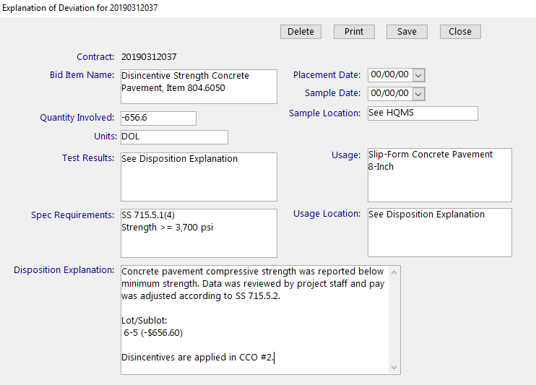
Figure: MIT Entry Disincentive Strength Concrete Pavement Example

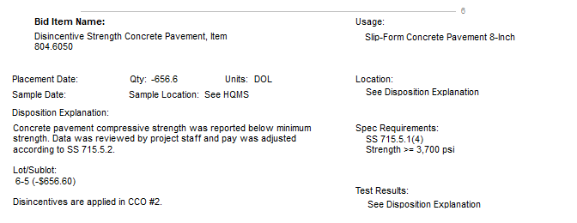
Figure: Printed DT1310 Disincentive Strength Concrete Pavement Example

